Lab 7

1. Generate an Erdos-Renyi random graph. Use a network of {102,103,104,5x104} nodes. Plot its degree distribution together with the theoretical prediction with respect to Binomial distribution as well as the Poisson distribution such that the equations for binomial distribution and Poisson distribution is as follows.



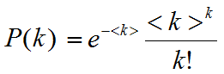

Your graph should look somewhat like the following figure as we have discussed into the class. You have to generate the graph only once and the degree distribution is to be generated in Python i.e. don’t use any other tool for the generation of degree distribution.

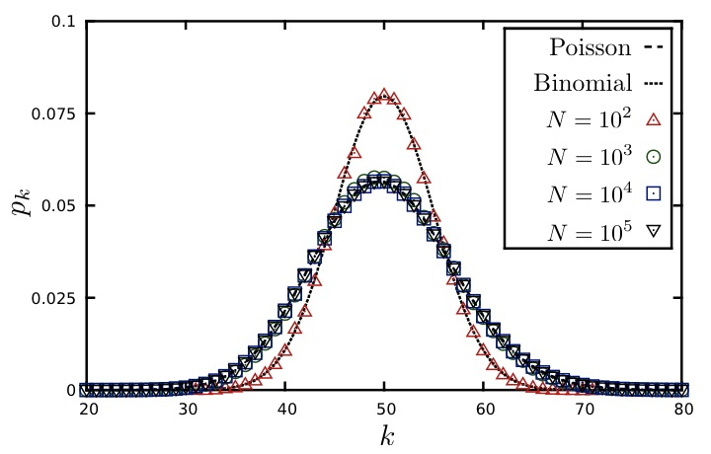

1. Scale-free networks are based on Preferential attachment based mechanism such that it can be understood with the help of following.

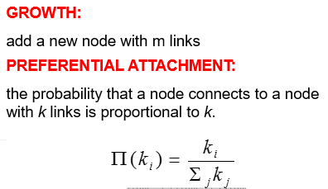

Note that LHS is not symbol of pi=3.14 but it is P(ki). You have to generate a network of 10,000 nodes such that a node gets attached to the existing network at time *t* with the given probability. Assuming value of m as {1,2}, generate this graph for each value of m. Simulate the generation of graph with only one iteration.